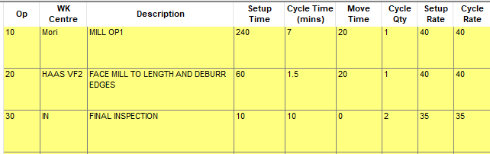
Drawing : 035838 , all ops machined on Haas VF2

Drawing 032736
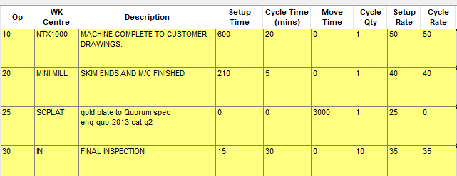

Drawing 031169
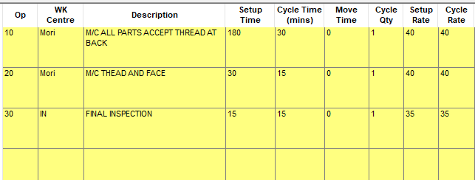
Drawing 029068
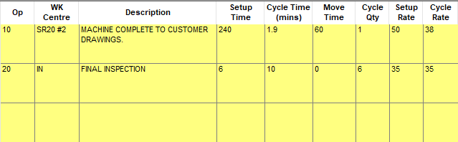

Drawing OLY014-01921
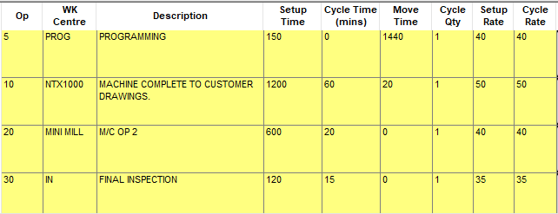

Drawing Naut-01695
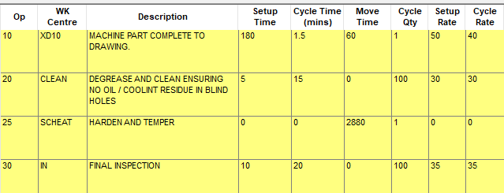

Drawing OLY014-01297
